

**TV Online shop project**

**Final Release Document**

**Group 1**

– Hanoi, August 2022 –

**Table of Contents**

I. Deliverable Package 3

1. How To Install JDK on Windows 3

2. How to Install NetBeans 8.2 6

2.1 How to Install NetBeans on Windows 6

2.2 How to Install NetBeans on macOS 6

2.3 How to Install NetBeans on Linux 6

III. User Manual 7

1. Overview 7

2. Common flow 7

# I. Deliverable Package

| **No.** | **File** | **Notes** |
| --- | --- | --- |
| 1 | XYZ_DB_final.sql | Database, including both table structures and table data |
| 2 | SRS Document_G1.docx | Final SRS (Requirement) Document |
| 3 | SDS Document_G1.docx | Final SDS (Design) Document |
| 4 | Final Product Backlog_G1.xlsx | Final status for the application functions, which include:  - Function name, feature, roles, function description (changes compared to the original requirements are highlighted)  - In Charge, Planned iteration & Actual iteration  - Final status & note on the update you made  - The links to the SRS & SDS are tracked |
| 5 | Issues Report_G1.xlsx | Final issues tracking list of the whole project |
| 6 | Project Tracking_G1.xlsx | Final tracking list of the whole project |

Other related deliverables:

* Tagged source codes: <https://github.com/duc123456/SWPP.git>

II. Installation Guides

## 1. How To Install JDK on Windows

Step 1: Un-Install Older Version(s) of JDK/JRE

I recommend that you install only the latest JDK. Although you can install multiple versions of JDK/JRE concurrently, it is messy.

If you have previously installed older version(s) of JDK/JRE, uninstall ALL of them. Goto "Control Panel" ⇒ (optional) "Programs" ⇒ "Programs and Features" ⇒ Uninstall ALL programs begin with "Java", such as "Java SE Development Kit ...", "Java SE Runtime ...", "Java X Update ...", and etc.

Step 2: Download JDK

1. Goto Java SE download site @ [http://www.oracle.com/technetwork/java/javase/downloads/index.html](http://web.archive.org/web/20190415195231/http://www.oracle.com/technetwork/java/javase/downloads/index.html).
2. Under "Java Platform, Standard Edition" ⇒ "Java SE 11.0.{x}", where {x} denotes a fast running security-update number ⇒ Click the "Oracle JDK" "Download" button.
3. Under "Java SE Development Kit 11.0.{x}" ⇒ Check "Accept Licence Agreement".
4. Choose the JDK for your operating system, i.e., "Windows". Download the "exe" installer (e.g., "jdk-11.0.{x}_windows-x64_bin.exe" - about 150MB).

Step 3: Install JDK

Run the downloaded installer (e.g., "jdk-11.0.{x}_windows-x64_bin.exe"), which instals both the JDK and JRE.

By default, JDK is installed in the directory "C:\Program Files\Java\jdk-11.0.{x}", where {x} denotes the update number. Accept the defaults and follow the screen instructions to install JDK.

Use your "File Explorer", navigate to "C:\Program Files\Java" to inspect the sub-directories. Take note of your JDK installed directory, in particular, the update number {x}, which you will need in the next step.

In the following diagram, the JDK installed directory is "C:\Program Files\Java\jdk-11.0.1", where {x}=1.

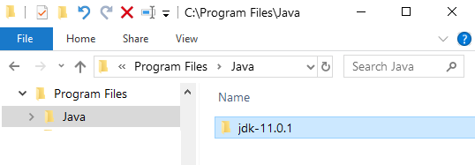

I shall refer to the **JDK installed directory** as **<JAVA_HOME>**, hereafter, in this article.

#### Step 3: Include JDK's "bin" Directory in the PATH

Windows' Command Prompt (CMD) searches the current directory and the directories listed in the PATH environment variable (or system variable) for executable programs. JDK's programs (such as Java compiler "javac.exe" and Java runtime "java.exe") reside in the sub-directory "bin" of the JDK installed directory. You need to include JDK's "bin" in the PATH to run the JDK programs.

To edit the PATH environment variable in Windows 10:

1. Launch "Control Panel" ⇒ (Optional) "System and Security" ⇒ "System" ⇒ Click "Advanced system settings" on the left pane.
2. Switch to the "Advanced" tab ⇒ Click the "Environment Variables" button.
3. Under "System Variables" (the bottom pane), scroll down to select the variable "Path" ⇒ Click "Edit...".
4. You shall see a **TABLE** listing all the existing PATH entries (if not, goto next step). Click "New" ⇒ Click "Browse" and navigate to your JDK's "bin" directory, i.e., "c:\Program Files\Java\jdk-11.0.{x}\bin", where {x} is your installation update number ⇒ Select "Move Up" to move this entry all the way to the TOP.

*Skip the next step.*

1. Variable value : c:\Program Files\Java\jdk-11.0.{x}\bin;[do not delete exiting entries...]

#### Step 4: Verify the JDK Installation

Launch a CMD via one of the following means:

1. Click "Search" button ⇒ Enter "cmd" ⇒ Choose "Command Prompt" or
2. Right-click the "Start" button ⇒ run... ⇒ enter "cmd", or
3. Click "Start" button ⇒ Windows System ⇒ Command Prompt

Issue the following commands to verify your JDK installation:

Issue "path" command to list the contents of the PATH environment variable. Check to make sure that your JDK's "bin" is listed in the PATH.  
path

PATH=c:\Program Files\Java\jdk-11.0.{x}\bin;[other entries...]

Issue the following commands to verify that JDK/JRE are properly installed and display their version:  
// Display the JDK version

javac -version

javac 11.0.1

// Display the JRE version

java -version

java version "11.0.1" 2018-10-16 LTS

Java(TM) SE Runtime Environment 18.9 (build 11.0.1+13-LTS)

Java HotSpot(TM) 64-Bit Server VM 18.9 (build 11.0.1+13-LTS, mixed mode).

#### Step 5: (Optional) Download JDK API Documentation, Demos and Samples

The JDK download does not include the documentation, which needs to be downloaded separately. In the past, I always insisted that my students should have a local copy of JDK API Documentation. But, today, you can easily access the online copy by googling "JDK 11 Documentation".

To install JDK API documentation:

1. From the Java SE download page (<http://www.oracle.com/technetwork/java/javase/downloads/index.html)> , under "Additional Resources", look for "Java SE 11 Documentation" ⇒ Click "Download" ⇒ Check "Accept the licence agreement" ⇒ Download the zip-file (e.g., "jdk-11.0.{x}_doc-all.zip" - about 50MB).
2. Unzip into the JDK installed directory <JAVA_HOME>. The documentation will be unzipped into "<JAVA_HOME>\docs". Browse the JDK documentation by opening "<JAVA_HOME>\docs\index.html".

You should also download the "JDK x Samples and Demos", and study these samples.

#### Step 6: (For Advanced Users Only) JDK's Source Code

Source code for JDK is provided and kept in "<JAVA_HOME>\lib\src.zip" (or "<JAVA_HOME>\src.zip" prior to JDK 9). I strongly recommend that you to go through some of the source files such as "String.java", "Math.java", and "Integer.java", under "java\lang".

## 2. How to Install NetBeans 8.2

### 2.1 How to Install NetBeans on Windows

#### Step 0: Install JDK

To use NetBeans for Java programming, you need to first install the Java Development Kit (JDK). See "[JDK - How to Install](http://web.archive.org/web/20190415195331/http://www3.ntu.edu.sg/home/ehchua/programming/howto/JDK_HowTo.html) ".

#### Step 1: Download

Download "NetBeans IDE" installer from [http://netbeans.org/downloads/index.html](http://web.archive.org/web/20190415195331/http://netbeans.org/downloads/index.html) . There are many "bundles" available. For beginners, choose the 1st entry "Java SE" (e.g., "netbeans-8.2-javase-windows.exe " 95MB).

#### Step 2: Run the Installer

Run the downloaded installer.

### 2.2 How to Install NetBeans on macOS

To use NetBeans for Java programming, you need to first install JDK. Read "[How to install JDK on Mac](http://web.archive.org/web/20190415195331/http://www3.ntu.edu.sg/home/ehchua/programming/howto/JDK_HowTo.html#jdk_mac) ".

To install NetBeans:

1. Download NetBeans from [http://netbeans.org/downloads/](http://web.archive.org/web/20190415195331/http://netbeans.org/downloads/) . Set "Platform" to "Mac OS X". There are many "bundles" available. For beginners, choose "Java SE" (e.g., "netbeans-8.2-javase-macosx.dmg " 116MB).
2. Double-click the download Disk Image (DMG) file.
3. Double-click the "NetBeans 8.x.mpkg", and follow the instructions to install NetBeans. NetBeans will be installed under "/Applications/NetBeans ".
4. Eject the Disk Image (".dmg").

You can launch NetBeans from the "Applications".

Notes: To uninstall NetBeans, drag the "/Applications/NetBeans" folder to trash.

### 2.3 How to Install NetBeans on Linux

To use NetBeans for Java programming, you need to first install JDK. Read "[How to install JDK on Ubuntu](http://web.archive.org/web/20190415195331/http://www3.ntu.edu.sg/home/ehchua/programming/howto/JDK_HowTo.html#jdk_ubuntu)".

To install NetBeans:

1. Download NetBeans from [http://netbeans.org/downloads/](http://web.archive.org/web/20190415195331/http://netbeans.org/downloads/). Choose platform "Linux (x86/x64)" ⇒ "Java SE". You shall receive a sh file (e.g., " netbeans-7.x-ml-javase-linux.sh") in "~/Downloads".

Set the downloaded sh file to executable and run the sh file. Open a Terminal:  
$ cd ~/Downloads $ chmod a+x netbeans-7.x-ml-javase-linux.sh // Set to executable for all (a+x)

1. $ ./netbeans-7.x-ml-javase-linux.sh // Run  
   Follow the instructions to install NetBeans.

To start NetBeans, run the script "netbeans" in the NetBeans' bin directory:

$ cd netbeans-bin-directory

$ ./netbeans

# III. User Manual

## 1. Overview

Television Online Shop - SWP391's online TV sales system. In this system, users will easily find and buy televisions more easily. As for store owners, they will easily manage, sell TV and view sales statistics more easily.

## 2. Common flow

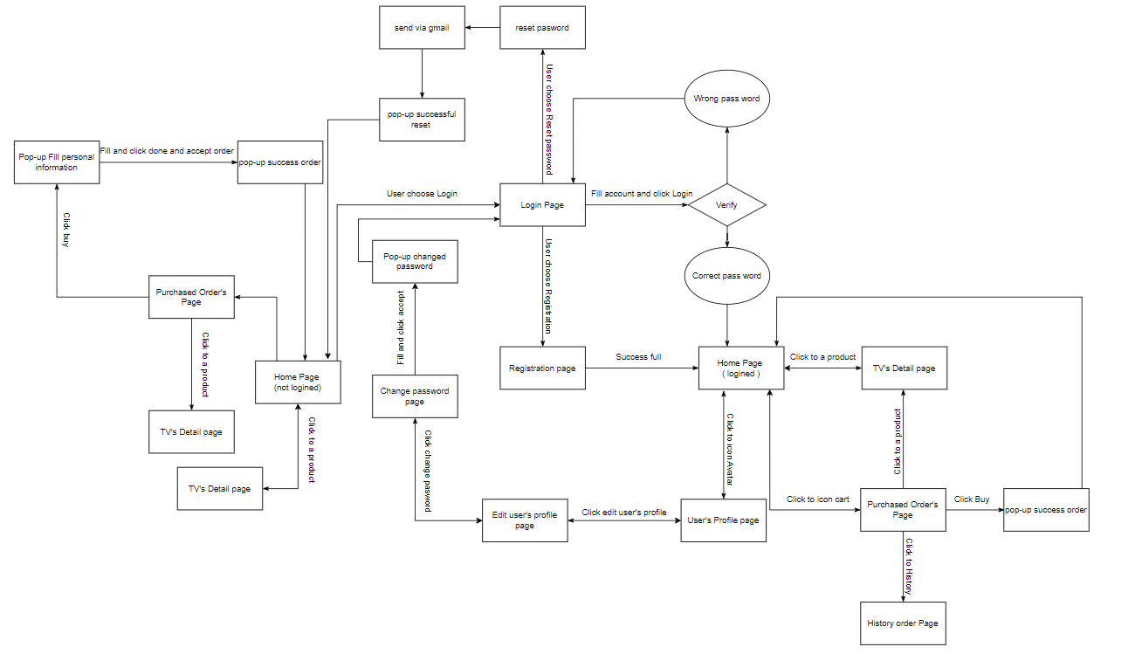

How to use:

Step 1: Sign up - user fill information in to sign up and click to “đăng ký”

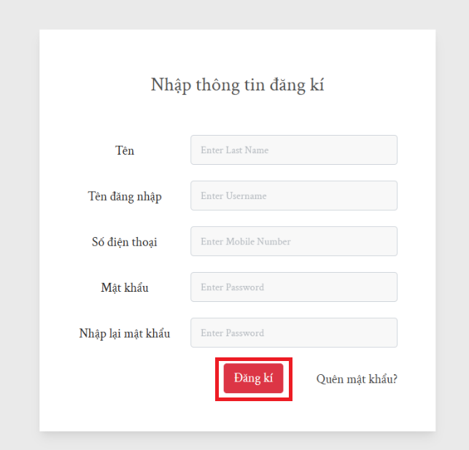

Step 2: back to home page click login button

Step 3: fill information and click “đăng nhập” button

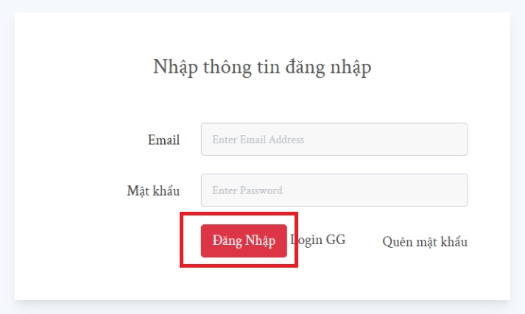

Step 4: User can overview a product

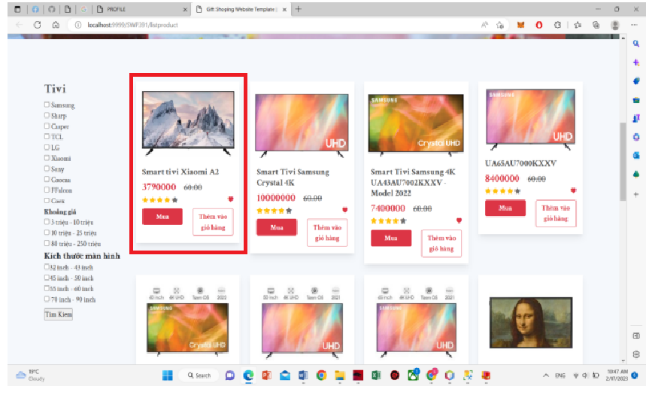

Step 5: View detail of product in cart and change quantity to add tin to cart

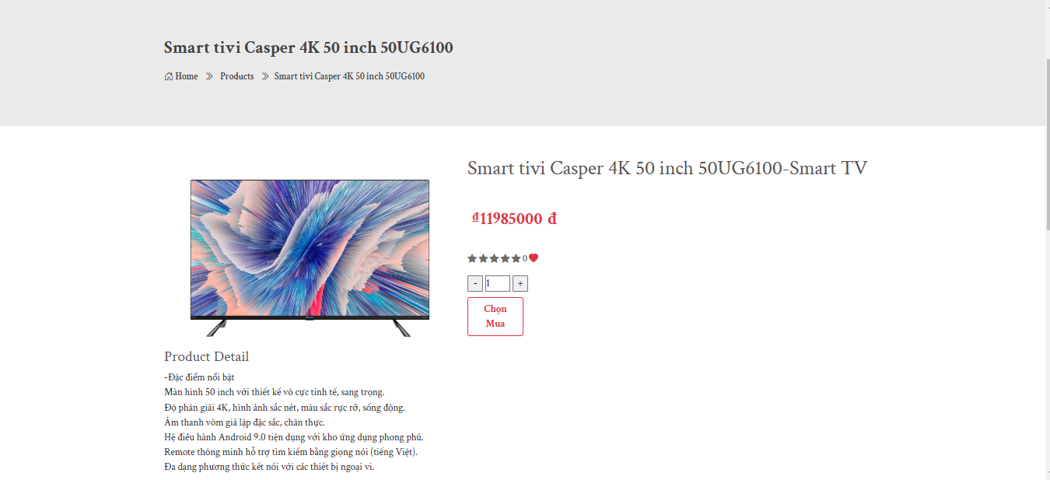

Step 6 : After add product to cart user can select “mua hàng” to buy

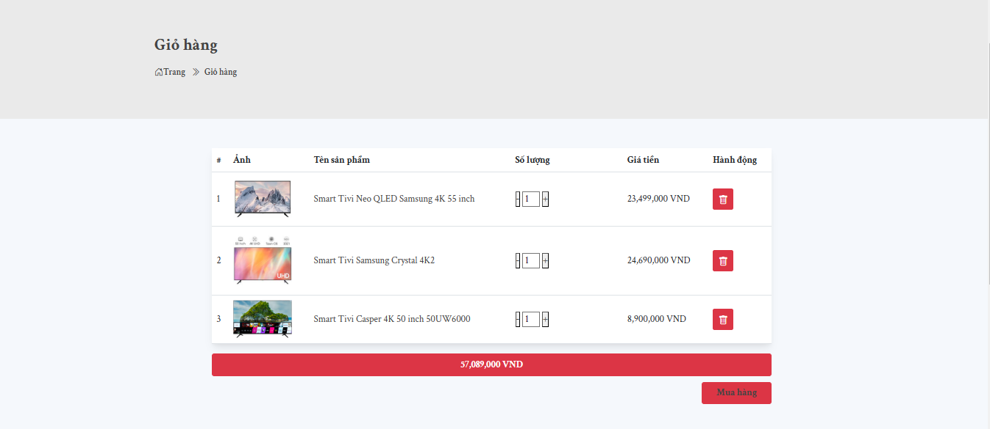

Step 7 : User fill information in to purchase and delivery

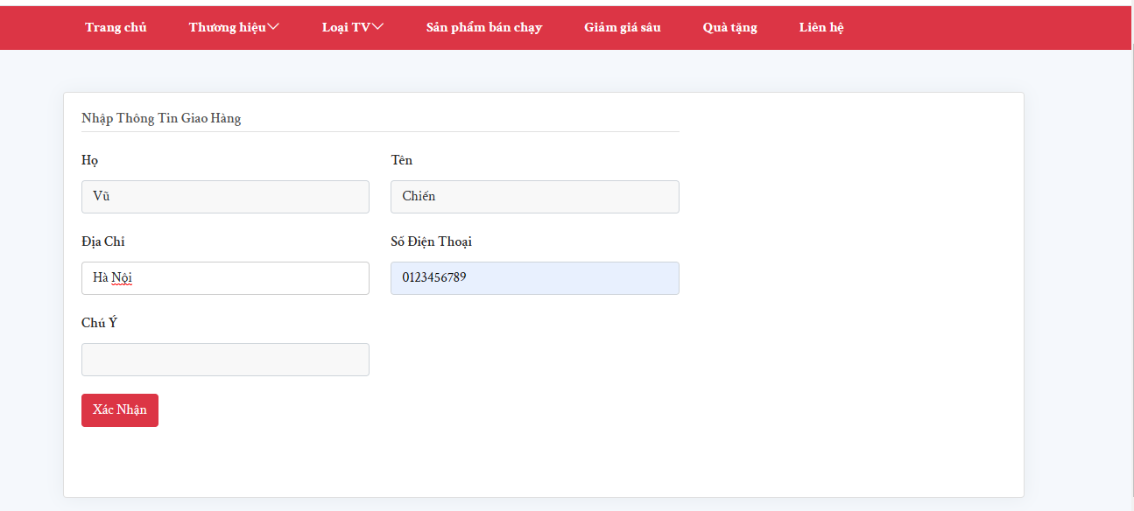

Step 8: User can tracking order and view history order

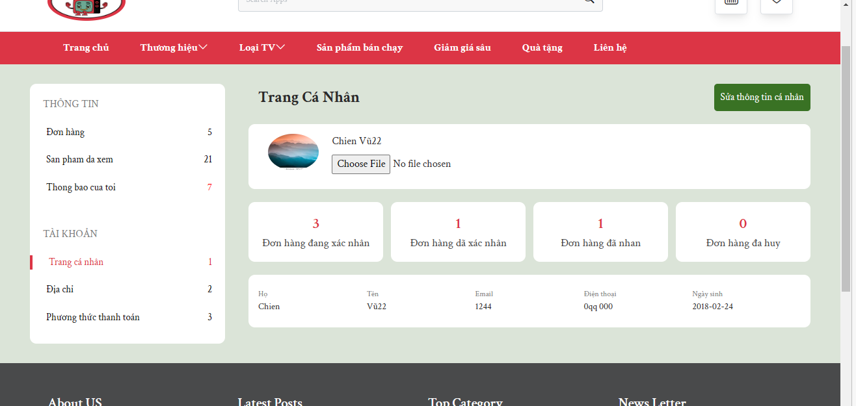

User also can :

- Click to icon avatar to view user profile

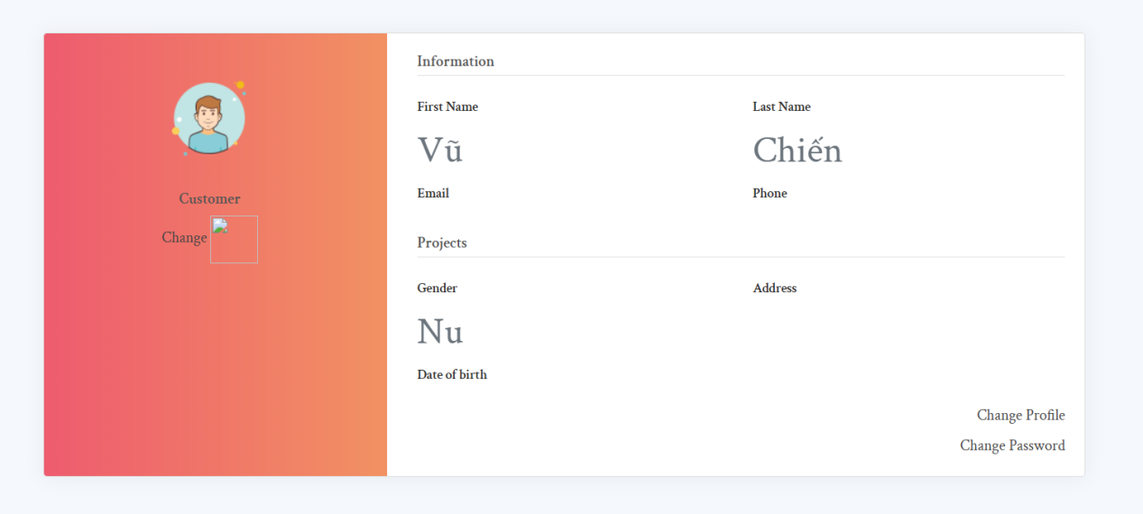

- If forgot pass word user can reset by email 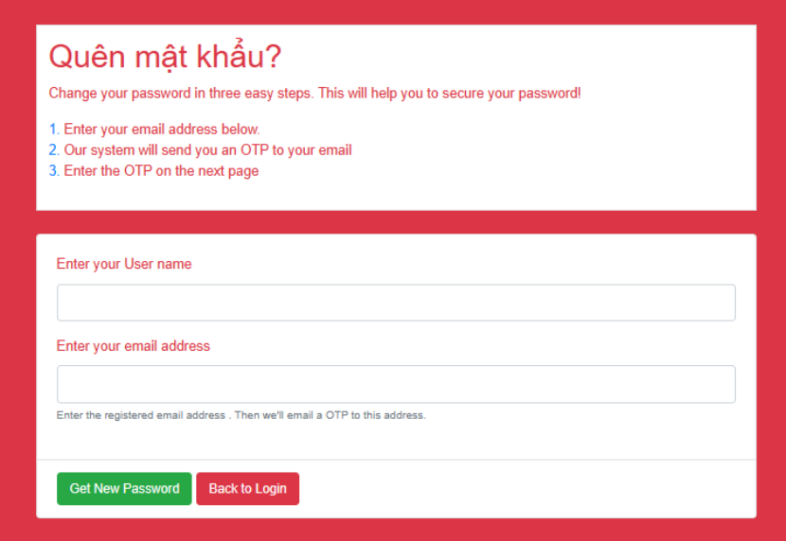

User at here can click change password: 